
Brandi Carlile performing “America the Beautiful” at the Super Bowl LX pre-game show.
Photo Credit: IMAGO / Imagn Images
Sennheiser Spectera Handheld Makes Broadcast Debut at the Big Game, Demonstrating the Future of Wireless Audio
Sennheiser Spectera raises the bar for wireless audio during Brandi Carlile’s rendition of “America the Beautiful,” while the Digital 6000 system reliably enables performances by Lady Gaga and Ricky Martin

San Francisco, CA, February 12, 2026 — As the Seattle Seahawks and New England Patriots faced off in the NFL’s biggest sporting event of the season on Sunday, Feb. 8, Sennheiser wireless solutions played a pivotal role in delivering pristine live audio throughout the Super Bowl LX broadcast. Brandi Carlile’s powerful rendition of “America the Beautiful” during the pre-game show marked the sparkling debut of a prototype Spectera SKM handheld, while the Apple Music Halftime Show brought memorable guest performances on the proven Sennheiser Digital 6000 wireless system by Lady Gaga and Ricky Martin.

Spectera is the world’s first wideband, bidirectional digital wireless ecosystem, enabling simultaneous audio transmission, system control, and monitoring within a single RF channel. It allows up to 64 channels (32 in/32 out) of simultaneous audio transmission, monitoring, and control within a single rack unit, significantly reducing RF complexity and improving stability.

Carlile’s performance featured a custom gold Spectera SKM handheld prototype and Neumann KK 205 microphone capsule, operating at an unmatched 1 millisecond (ms) latency with 96-kilohertz (kHz) audio resolution. The Spectera system’s ultra-low latency and high-definition signal path ensured exceptional vocal clarity and immediacy across the stadium and broadcast feed.

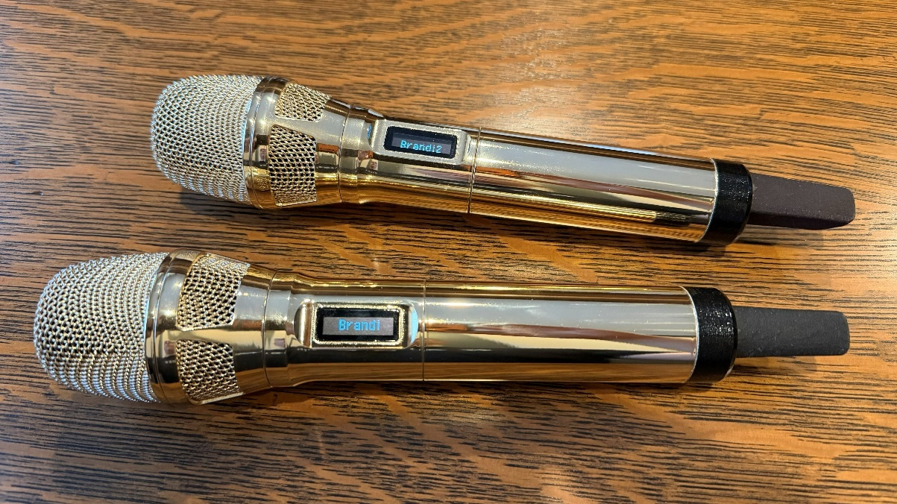
Brandi Carlile’s custom gold Spectera SKM handheld transmitters with the Neumann KK 205 microphone capsule. Photo credit: Greg Simon

The star-studded halftime show, led by Bad Bunny, featured dazzling guest performances by Lady Gaga and Ricky Martin, each using custom-finished Sennheiser Digital 6000 handheld transmitters, white for Gaga and silver for Martin. Their wireless microphones delivered the consistency, transparency, and reliability trusted by top-tier artists on the world’s biggest stages.

Across the event, seven Sennheiser wireless microphones and nine stereo in-ear systems operated using just 6 MHz of RF spectrum total, highlighting Spectera and Digital 6000’s exceptional spectral efficiency in one of live audio’s most congested RF environments. Jerry Streeter, monitor engineer for Brandi Carlile shares, “the clarity and stability were what stood out right away, there is no audible compression, the top end stays smooth on wedges, and the in-ears sound incredibly open. From an RF perspective, getting all that performance on a single TV channel is a game changer.”

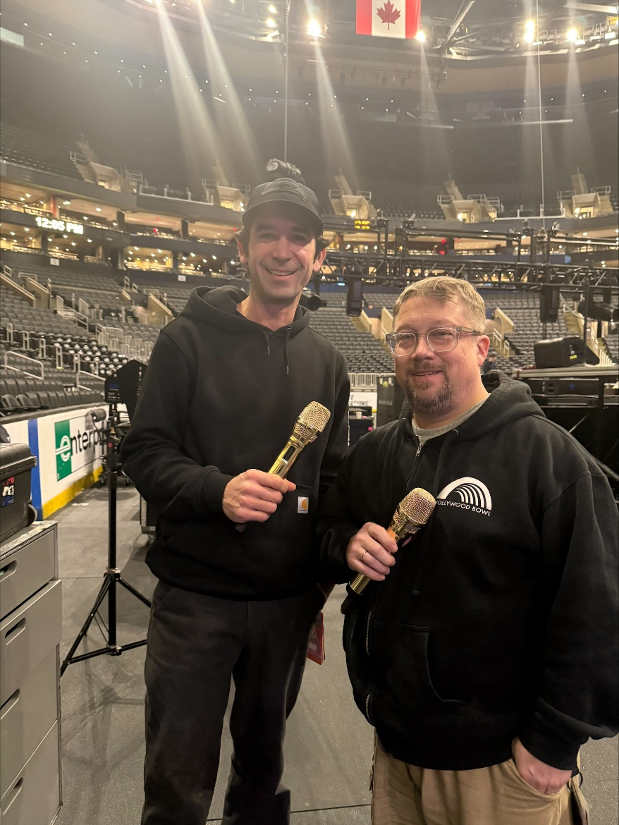
Brandi Carlile’s Monitor Engineer Jerry Streeter (L) and Front of House Engineer Sean Quackenbush (R) holding the custom gold Spectera handheld prototypes.

The path to the Spectera handheld transmitter’s Super Bowl LX debut began last year, when lead RF coordinator Cameron Stuckey collaborated with Sennheiser on the ambitious New York theater production Masquerade, where early Spectera in-ear monitoring systems demonstrated reliable, high-channel-count wireless performance in an exceptionally challenging RF environment. When Stuckey was later named lead RF coordinator for Super Bowl LX, that experience sparked discussions about whether Spectera could meet the unprecedented technical demands of the event.

“My comfort with Spectera came from deploying it on Masquerade, an immersive theater production spanning six floors and 13 performance spaces in the middle of New York City,” said Cameron Stuckey, lead RF coordinator for Super Bowl LX. “That project required high-density, bidirectional wireless in a complex structure environment, utilizing every feature of Spectera – device capacity, multi-zone operation, modulation diversity. It was the best demonstration of the system’s stability. Knowing the Sennheiser team was as committed to perfection as I was meant it was ready for any production.”

A key factor in bringing the Spectera handheld to the Big Game was the support of Sean Quackenbush, Brandi Carlile’s longtime front of house engineer, and her monitor engineer, Jerry Streeter, who have relied on Sennheiser and Neumann vocal solutions across Carlile’s live performances for many years. In preparation for the pre-game show, Quackenbush evaluated the Spectera handheld transmitter prototype alongside his preferred Neumann KK 205 capsule, and quickly recognized the system’s sonic advantages. “As a front-of-house engineer, the biggest thing for me is when I don’t have to work on a vocal mic to make it sound right,” said Quackenbush. “With Spectera, what I heard right away was how musical it was. The proximity effect felt natural, not exaggerated, and for the first time with a wireless handheld you’re really hearing the Neumann capsule itself. It has that German studio quality you expect in a controlled environment, but we were hearing it live, wirelessly, in a stadium. Once we heard that immediacy and clarity, it was hard to imagine going back.”

Quackenbush continued, “once we heard it come up in the stadium, it was one of those moments where you just know. The vocal felt incredibly stable at high volume, and I barely had to touch EQ. It sounded fantastic in that space. There’s nothing quite like it, and I’m fortunate that I get to push the fader up on it.”

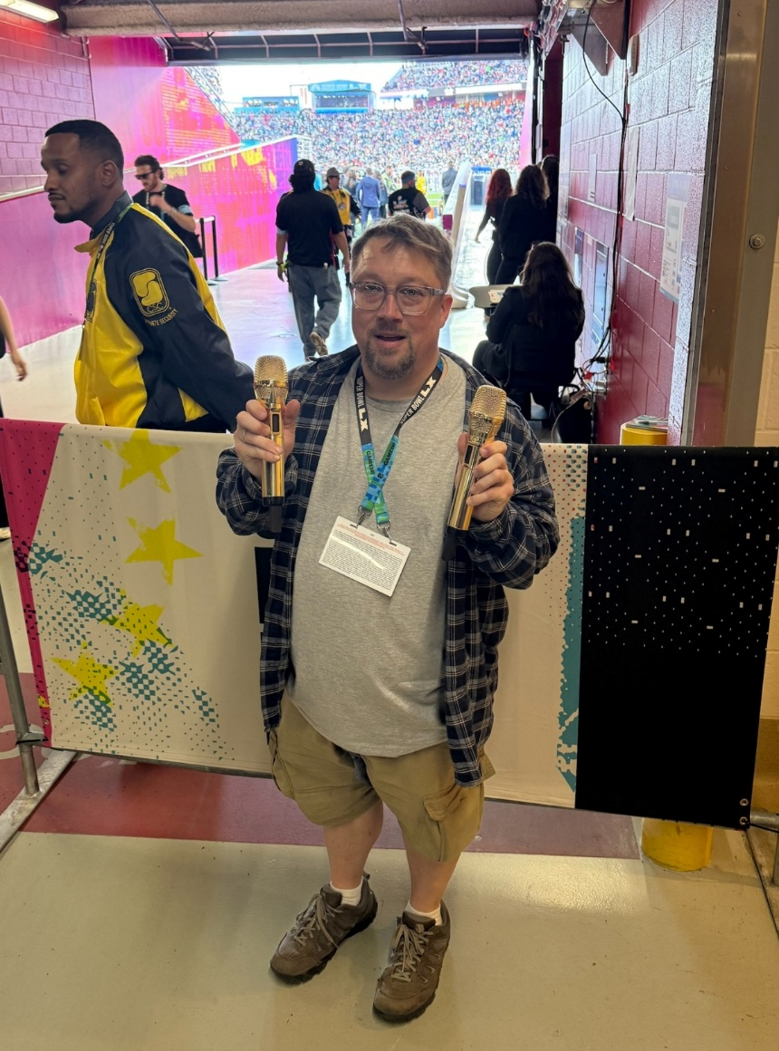
Sean Quackenbush at Super Bowl LX where the Spectera handheld made its broadcast debut during Brandi Carlile’s performance.

In the weeks leading up to the Big Game, Stuckey and Quackenbush worked closely with Sennheiser to prepare a custom prototype Spectera handheld transmitter for the broadcast.

To ensure seamless coverage through rehearsals and the live broadcast, the production team deployed three Sennheiser DAD antennas covering the stadium bowl, with an additional DAD antenna supporting backstage and preparation areas, “Spectera allows us to deploy antenna systems in a fraction of the time that coax-based narrowband systems require to get right,” Stuckey said. “Instead of compensating for lossy links or RF-Over-Fiber conversion artifacts, we define the coverage area, place the DAD antennas, and plug it in. Spectrum selection is the challenge of large events like Super Bowl. Having such a wide tuning range and access to 1G4 spectrum means that Spectera can be used on any show, regardless of size. You’ll see it on TV again soon.”

The broadcast debut of the Spectera handheld transmitter during Super Bowl LX highlighted Sennheiser’s next-generation wireless innovation, delivering pristine audio, ultra-low latency, and exceptional efficiency on one of the most-watched live broadcasts of the year.
For more information about Sennheiser and its solutions, visit www.sennheiser.com.
###

About the Sennheiser Brand – Over 80 Years of Building the Future of Audio
Building the future of audio and creating unique sound experiences for our customers - this is the aspiration that unites the employees of the Sennheiser Group worldwide. The independent, family-owned company Sennheiser was founded in 1945. Today, it is managed in the third generation by Dr. Andreas Sennheiser and is one of the leading manufacturers in the field of professional audio technology.

sennheiser.com | neumann.com | merging.com

Local Press Contacts  Daniella Kohan  daniella.kohan@sennheiser.com  +1 (860) 227-2235  InGear  Peter Schuyler  peter@ingearpr.com  +1 917-496-8970 | Global Press Contact  Stephanie Schmidt  stephanie.schmidt@sennheiser.com  +49 51306001275

